**PIZZA SALES SQL QUERIES**

**A. KPI’s**

**1. Total Revenue:**

SELECT SUM(total_price) AS Total_Revenue FROM pizza_sale;

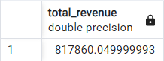

**2. Average Order Value**

SELECT (SUM(total_price) / COUNT(DISTINCT order_id)) AS avg_order_value FROM pizza_sale;

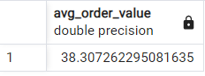

**3. Total Pizzas Sold**

SELECT SUM(quantity) AS Total_pizza_sold FROM pizza_sale;

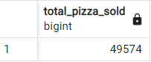

**4. Total Orders**

SELECT COUNT(DISTINCT order_id) AS Total_Orders FROM pizza_sale;

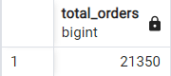

**5. Average Pizzas Per Order**

SELECT ROUND(ROUND (SUM(quantity),2) /

ROUND(COUNT (DISTINCT order_id),2),2)

AS avg_pizzas_per_order

FROM pizza_sale;

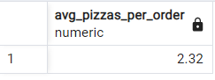

**B. Daily Trend for Total Orders**SELECT TO_CHAR(order_date, ‘Day’) AS order_day, COUNT(DISTINCT order_id) AS total_orders

FROM pizza_sale

GROUP BY TO_CHAR(order_date, ‘Day’)

ORDER BY total_orders DESC;

***Output:***

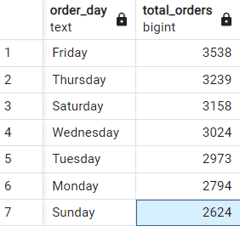

**C. Monthly Trend for Orders**

select TO_CHAR(order_date, ‘MONTH’) as month_name, COUNT(DISTINCT order_id) as total_orders

from pizza_sale

GROUP BY TO_CHAR(order_date, ‘MONTH’)

ORDER BY total_orders

***Output***

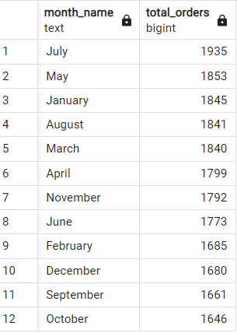

**D. % of Sales by Pizza Category**

SELECT pizza_category, CAST(SUM(total_price) AS DECIMAL(10,2)) as total_revenue,

CAST(SUM(total_price) * 100 / (SELECT SUM(total_price) from pizza_sale) AS DECIMAL(10,2)) AS PCT

FROM pizza_sale

GROUP BY pizza_category

***Output***

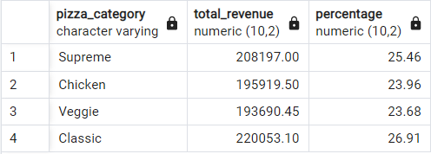

**E. % of Sales by Pizza Size**

SELECT pizza_size, CAST(SUM(total_price) AS DECIMAL(10,2)) as total_revenue,

CAST(SUM(total_price) * 100 / (SELECT SUM(total_price) from pizza_sale) AS DECIMAL(10,2)) AS percentage

FROM pizza_sale

GROUP BY pizza_size

ORDER BY pizza_size

***Output***

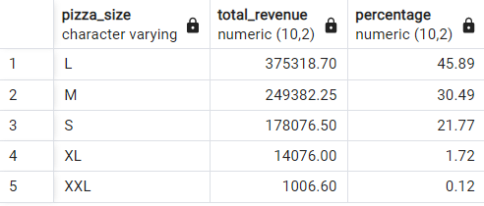

**F. Total Pizzas Sold by Pizza Category**

SELECT pizza_category, SUM(quantity) as total_quantity_sold

FROM pizza_sale

GROUP BY pizza_category

ORDER BY total_quantity_sold DESC

***Output***

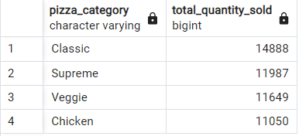

**G. Top 5 Pizzas by Revenue**

SELECT pizza_name, SUM(total_price) AS total_revenue

FROM pizza_sale

GROUP BY pizza_name

ORDER BY total_revenue DESC

LIMIT 5

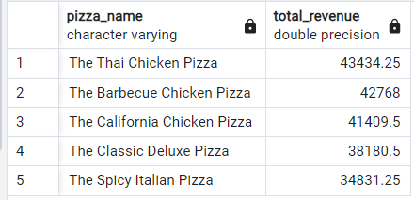

**H. Bottom 5 Pizzas by Revenue**

SELECT pizza_name, SUM(total_price) AS Total_Revenue

FROM pizza_sale

GROUP BY pizza_name

ORDER BY Total_Revenue ASC

LIMIT 5

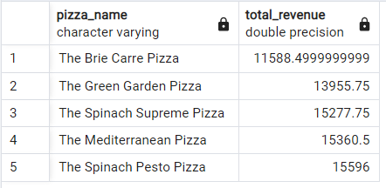

**I. Top 5 Pizzas by Quantity**

SELECT pizza_name, SUM(quantity) AS Total_Pizza_Sold

FROM pizza_sale

GROUP BY pizza_name

ORDER BY Total_Pizza_Sold DESC

LIMIT 5

***Output***

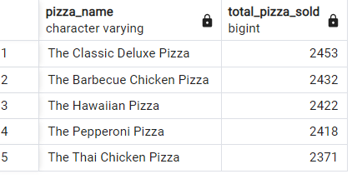

**J. Bottom 5 Pizzas by Quantity**

SELECT pizza_name, SUM(quantity) AS Total_Pizza_Sold

FROM pizza_sale

GROUP BY pizza_name

ORDER BY Total_Pizza_Sold ASC

LIMIT 5

***Output***

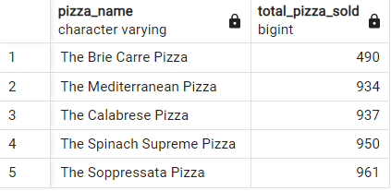

**K. Top 5 Pizzas by Total Orders**

SELECT pizza_name, COUNT(DISTINCT order_id) AS Total_Orders

FROM pizza_sale

GROUP BY pizza_name

ORDER BY Total_Orders DESC

LIMIT 5

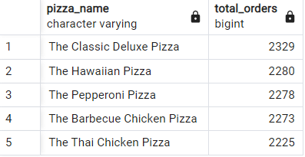

**L. Borrom 5 Pizzas by Total Orders**

SELECT pizza_name, COUNT(DISTINCT order_id) AS Total_Orders

FROM pizza_sale

GROUP BY pizza_name

ORDER BY Total_Orders ASC

LIMIT 5

